
Contents

AI System Description

Adaptive Triage

INTERNAL

1. How to use this template 3
1.1 System Identity 3
1.2 Summary 3
2. System Overview (C4) 4
2.1 Business Context and Objectives 4
3. Intended Use and Users (C9) 5
3.1 Problem Statement 5
3.2 Rationale for Using AI 5
3.3 Success Criteria 5
4. Architecture and Components (C4) 6
4.1 Component Inventory 6
4.2 Tooling and Approval Status 6
5. Model and Component Selection Rationale (C4) 8
6. Data Dependencies 9
7. Logging and Telemetry (C7) 10
8. User and Operator Information (C9) 11
9. Known Limitations and Failure Modes (C9) 12
10. Non-Functional Requirements 13
11. Retirement Plan 14
12. Maintenance and Support 15
13. Change History 16

How to use this template
This template captures the AI System Description (Model/System Card) for an AI system delivered or operated by Kainos. It is one of the four mandatory artefacts defined in the Kainos AI Framework Policy and is the single source of truth for what the system is, how it works, what it uses, and its limitations. It supports controls C4, C7, and C9.
Complete every section. Use [square-bracketed grey text] as fillable placeholders. Cross-reference the Risk and Impact Assessment, Data Management Record, and Monitoring and Review Record for the same system. Italic guidance text in this template should be removed once the section is completed.

System Identity
Field | Value
AI System Name | Adaptive Triage
OneTrust Assessment | 13278
Risk Tier | Tier 3 - High (working assumption because the Kainos AI Lifecycle Policy explicitly lists medical triage support as a Tier 3 example; formal classification remains subject to the AI Governance Forum).
Customer (if applicable) | NHS England
Data Governance Role | Processor - proposed working position for Kainos delivery of the service on behalf of NHS England
Data Controller | NHS England, subject to confirmation through the Data Management Record / DPIA and contractual governance.
Monitoring Owner | Shared - Kainos will implement and operate technical/model monitoring within the delivered service, with NHS England retaining customer and clinical governance accountability.
Accountable Owner | Laura Jones, Head of Product, NHS Pathways, NHSE
Approver | Susan Main, Delivery Manager, Adaptive Triage
Reviewer(s) | Security; Clinical Safety; Data/AI Ethics; Quality Assurance; Information Governance / Data Protection; Legal / Compliance; Architecture and relevant clinical reviewers, as required.
Lifecycle Stage | Develop - Alpha progressing towards Beta, with design, implementation, evaluation and clinical assurance activities underway.
Version | v0.1
Date | 21st September 2026
Status | Final version

Summary
Key points to capture in this artefact:
- What the system does and who it is for.
- How it is built (architecture, components, models).
- Why those choices were made (selection rationale).
- What it depends on (data, services, sub-processors).
- What it logs and how that logging supports oversight.
- What users and operators must know to use it safely.
- Known limitations and out-of-scope uses.

System Overview (C4)
Provide a concise plain-English description of the system: the business problem it solves, the value it delivers, and the boundary of the system.
Probabilistic AI Triage Opportunity
NHS England’s national triage service supports NHS 111, 999, and 111 Online through NHS Pathways, conducting over 33 million assessments each year and safely directing 92% of patients away from A&E. The current system uses a deterministic approach, following predefined rules and question pathways based on patient responses.
Probabilistic triage offers a new approach by using statistical models to assess the likelihood of different conditions and outcomes. Unlike fixed decision trees, it dynamically adapts questions, provides confidence levels for recommendations, and has the potential to improve the speed, accuracy, and explainability of triage decisions.
NHS England is exploring this opportunity because of the extensive national triage data collected through NHS Pathways, combined with linked hospital admission and secondary care datasets. This rich real-world evidence creates the potential to develop probabilistic models that can predict patient outcomes more effectively and unlock new capabilities in clinical triage.
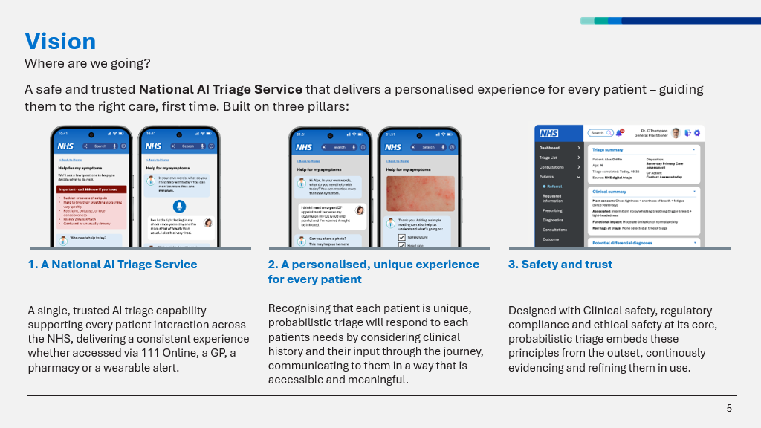

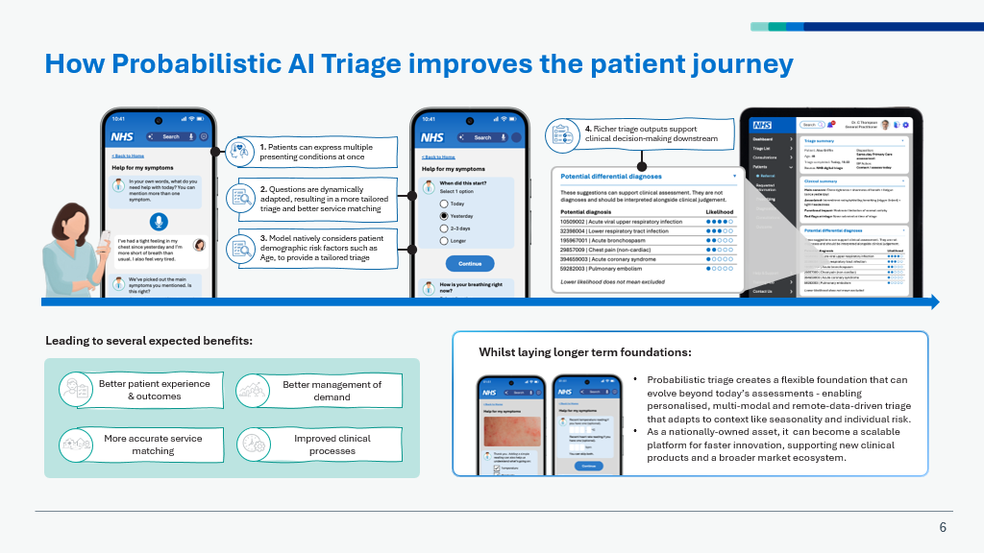

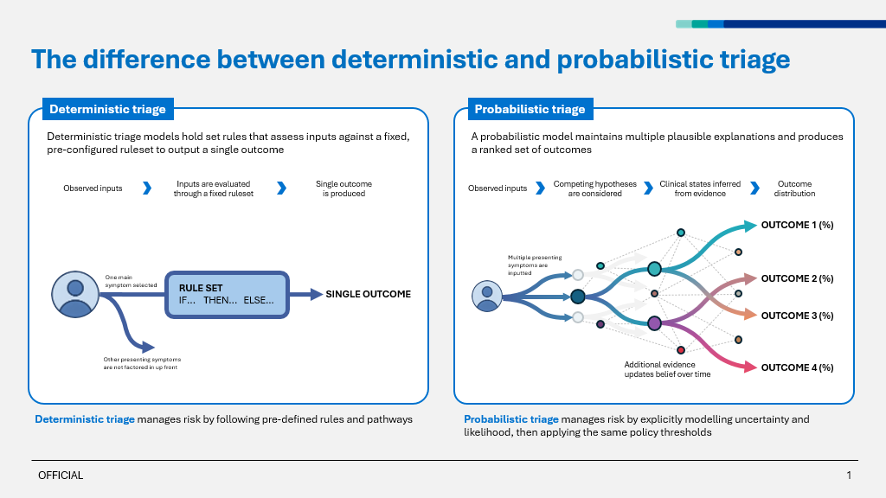

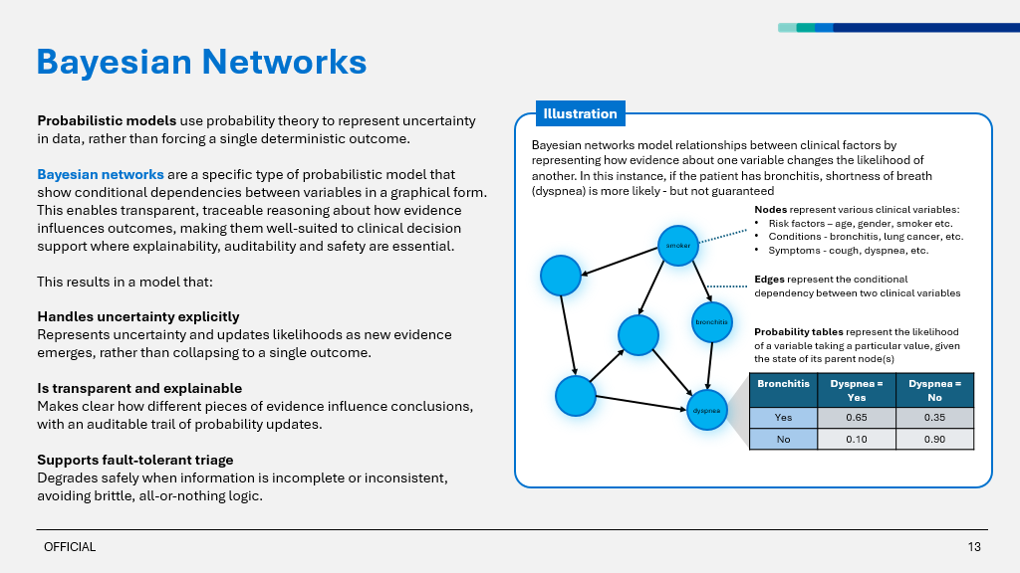

The system boundary includes the model build and release pipeline, approved Bayesian Network artefacts, runtime inference and safety policy, the API interaction layer, evaluation/testing capability, model governance/clinical administration capability, and the logging/monitoring required to operate the service safely. Public-facing channel presentation and unrelated downstream service-selection components sit outside the core Adaptive Triage system boundary, although their interfaces with the service are governed and tested.

Business Context and Objectives
State the business objectives the system supports, expected benefits, and success measures.
Adaptive Triage supports NHS England's objective to improve digital urgent and emergency care triage by making assessments more responsive to the individual evidence presented by the patient while retaining clinical safety, governance and explainability. Expected benefits are: reducing unnecessary or low-value questions; improving the ability to reason across multiple symptoms and risk factors; directing people to the most appropriate care setting first time; reducing avoidable onward referrals and emergency department attendances where clinically appropriate; improving patient experience; and supporting more efficient downstream clinical processes. Business success will be measured through agreed Beta/pilot measures covering assessment efficiency, patient experience, appropriate service matching and downstream impact, yet to be defined.

Intended Use and Users (C9)
Describe the intended use cases, the users and operators, and any explicit out-of-scope uses.
Aspect | Description
Primary intended use | To provide clinically governed probabilistic triage reasoning that combines evidence gathered during an assessment, dynamically selects appropriate next questions and returns the most appropriate route and urgency of care.
Primary users | Primary service users are people accessing NHS digital urgent and emergency care through approved consuming channels. Direct operational users include clinicians, clinical authors and authorised administrators responsible for model review, assurance and governance.
Operators / oversight role | Kainos/NHS England delivery and operational teams operate and monitor the service according to the agreed support model. Clinical reviewers and the Clinical Safety Officer provide clinical oversight; Product/Delivery owns lifecycle governance; Security, QA, AI Ethics and IG/Legal provide specialist assurance. Named owners are to be recorded once formally assigned.
Out-of-scope uses | Autonomous diagnosis; unrestricted general medical advice; replacement of clinician judgement where human review is required; use outside approved triage pathways/populations/channels; runtime use of a general-purpose LLM to determine triage outcomes; use of unapproved model artefacts or safety configurations; secondary use of outputs for eligibility, employment, insurance or other unrelated decision-making.
Deployment context | Patient-facing NHS service consumed through approved NHS digital channels/integrating services. Hosted in an approved UK AWS environment for NHS England. Clinical administration/governance access is restricted to authorised users.

Problem Statement
The current NHS digital triage capability (Pathways) is designed around structured, deterministic, rules-based question flows that provide consistency and safety. That same design is built around a single main presenting symptom, applies demographics through fixed thresholds, follows a pre-defined question flow, makes limited use of the rich clinical data held across the NHS, and can only be improved through manual rule changes and clinical review. ​
​As a result, patients can be routed through oversimplified pathways, some are over-referred, and downstream clinicians often re-triage. In addition, patients are increasingly seeking health advice from general-purpose LLMs exposing them to unregulated, clinically unverified advice, undermining established NHS triage channels.​

Rationale for Using AI
An AI/probabilistic approach is appropriate because the problem requires reasoning under uncertainty across multiple interacting pieces of clinical evidence and adapting the assessment as new evidence becomes available. A Bayesian Network provides an explicit probabilistic model of relationships between evidence and clinical states, allowing posterior probabilities to be updated in a transparent and testable way. Alternatives considered include continuing with deterministic pathways only, using a single monolithic Bayesian Network, using specialised/federated Bayesian Networks, distributing probabilistic decision-making into consuming services, and using generative LLMs for runtime reasoning. The current direction is a centralised Adaptive Triage service using clinically governed Bayesian inference, with a hierarchical/federated topology where appropriate. Runtime generative LLM decision-making is excluded because the programme requires predictable, reproducible, auditable and clinically approvable reasoning.

2.4 Success Criteria
Adaptive Triage will be considered successful if it demonstrates, through Beta/pilot evidence, that it can reduce unnecessary assessment burden while maintaining clinically acceptable triage outcomes. Business measures will cover: reduction in average/median questions or assessment effort relative to the agreed deterministic baseline; user/patient experience; Numeric targets are yet to be determined.

Architecture and Components (C4)
What to include:
All the AI components themselves (model(s), orchestrator, vector store, guardrails, agent tools).
Any non-AI component that touches the AI - i.e. feeds its inputs, consumes its outputs, or sits inside its trust boundary. Examples: the data source/RAG pipeline feeding it, the auth layer in front of it, the downstream service that acts on its decisions.
What you can leave out:
Non-AI parts of the solution that don't interact with the AI (e.g. an unrelated billing or reporting module). For those, reference your normal solution-architecture documentation rather than duplicating it. You do not need to inventory every component of the entire solution.

Component Inventory
Component | Type | Provider / version | Hosting / region | Role in the system
Bayesian Network model artefact(s) | Probabilistic AI / Bayesian Network | Adaptive Triage controlled model version(s); exact version per release | AWS UK region / controlled artefact store | Represents clinically governed probabilistic relationships and conditional probabilities used by the runtime inference engine.
BN build pipeline | AI/model engineering pipeline | Kainos/NHS England implementation; versioned pipeline | AWS UK region | Transforms approved clinical source material/data into candidate model structures/CPTs, applies checks and produces versioned model artefacts for review and approval.
Inference engine | Probabilistic inference service | Adaptive Triage runtime implementation | AWS UK region | Loads an approved model artefact, incorporates evidence, updates probabilities and exposes controlled inference functions to the interaction workflow.
Safety / risk policy layer | Rule/policy-based safety control | Adaptive Triage configuration, versioned per release | AWS UK region | Applies approved safety guardrails, thresholds, channel policies, stopping/escalation rules and other controls around probabilistic inference.
Federation / model orchestration layer | Probabilistic model orchestration | Adaptive Triage implementation | AWS UK region | Routes or combines reasoning across specialised Bayesian Networks where the hierarchical/federated topology is used.
FHIR-aligned Adaptive Triage API | API / interaction layer | Adaptive Triage API; versioned contract | AWS UK region | Receives structured assessment evidence from approved consuming services and returns structured triage interaction/outcome data.
Clinical Admin / Model Governance UI | Governance application | Adaptive Triage clinical governance capability | AWS UK region | Allows authorised users to inspect model structure/CPTs, manage draft safety settings, review evidence, approve controlled changes and inspect model/release history.
Evaluation capability | Testing and evaluation platform | Adaptive Triage test integration | Approved environment | Runs vignettes, regression, safety, calibration, robustness and other evaluation activity against candidate/released models.

Tooling and Approval Status
List all tooling used to develop, evaluate, monitor, and govern the AI system. For each tool, record its status against the AI Governance approved tooling list. Where a tool is not on the approved tooling list, reference the relevant Approvals & Exceptions Log entry authorising its use. Where the use of a tool is mandated or approved by the customer, record the status as "Customer Approved" and include any supporting customer approval or contractual requirement where available.
Tool / platform | Category | Approved-list status | Approval reference
AWS Bedrock | Model gateway / build-time AI assistance | Customer/Engineering Board approved for programme use; Kainos approved-list status to be confirmed | NHSE Engineering Board approval received on14th August 2026
Approved Bedrock foundation model(s) | LLM / build-time assistance | Use only models approved for the programme and Kainos governance; exact model/version recorded per activity | NHSE Engineering Board approval received on14th August 2026
Amazon SageMaker | Model development / data science | Customer/Engineering Board approved for programme use; Kainos approved-list status to be confirmed | NHSE Engineering Board approval received on14th August 2026
Amazon Neptune | Graph database / model storage | Customer/Engineering Board approved for programme use; Kainos approved-list status to be confirmed | NHSE Engineering Board approval received on14th August 2026
Amazon CloudWatch | Monitoring / observability | Approved AWS platform service subject to project platform/security governance | Standard NHS Approved tooling
Amazon S3 | Artefact / evidence storage | Approved AWS platform service subject to project platform/security governance | Standard NHS Approved tooling
Bayesian inference libraries / implementation | Probabilistic model execution | Version-controlled project dependency; exact library/version to be recorded at release | Standard NHS Approved tooling
FHIR tooling / interoperability libraries | API / interoperability | Provided/assured with support from NHS interoperability experts; exact tooling/version to be recorded | Standard NHS Approved tooling

Model and Component Selection Rationale (C4)
Record the rationale for each material model, tool, or component used by the system. Where a component was selected by Kainos, document alternatives considered and the rationale for selection. Where a component was mandated by the customer, regulator, or existing enterprise architecture, record the source of the requirement.
Decision | Selection owner | Options considered | Selected option | Rationale (incl. trade-offs)
Clinical reasoning model | Joint | Deterministic-only pathways; Bayesian Network; opaque ML classifier; runtime LLM | Bayesian Network | Supports explicit reasoning under uncertainty, incremental evidence updates, inspectable structure/CPTs and reproducible outcomes. More explainable and clinically governable than an opaque runtime model while offering greater adaptivity than fixed deterministic flows.
Runtime generative AI | Joint | General-purpose LLM runtime reasoning; constrained LLM; no LLM at runtime | No general-purpose LLM used for runtime triage decision-making | Excludes a source of non-deterministic/unbounded runtime behaviour and preserves reproducibility, clinical approval and traceability. LLMs are restricted to controlled build-time assistance with human review.
BN topology | Joint | Single monolithic BN; multiple isolated specialist BNs; hierarchical/federated BN | Hierarchical/federated BN direction | Provides manageable clinically coherent models while allowing reasoning across specialised clinical families through controlled orchestration/aggregation. Final detailed topology remains subject to design/ADR approval.
Inference ownership | Joint | Centralised service; decision-making distributed to integrating services | Centralised Adaptive Triage inference service | Provides one governed source of probabilistic decision logic, safety rules, model versions, logging and clinical assurance, reducing divergence between channels.
Hosting model | Customer / Joint | On-premises; alternative cloud; AWS | NHS England approved AWS environment | Aligns with the programme hosting environment and enables use of approved AWS security, data, model-development and observability services.
Build-time LLM access | Joint | Direct external model APIs; self-hosted models; AWS Bedrock | AWS Bedrock | Provides a controlled enterprise gateway to approved models and keeps build-time AI use inside the agreed AWS governance/security boundary. All outputs remain subject to human/clinical review.
Graph/model storage | Joint | Relational/document store; Neo4j; Amazon Neptune | Amazon Neptune / controlled model artefact storage | Supports graph-oriented representation and traversal in the approved AWS environment. Final use is governed by the implementation architecture and immutable released artefacts remain the authoritative runtime input.
Clinical governance interface | Kainos / Joint | Configuration via code only; separate tools/spreadsheets; dedicated governance UI | Dedicated Clinical Admin / Model Governance capability | Provides controlled, auditable review of model structure, CPTs, safety settings, evidence and approvals, reducing reliance on disconnected manual artefacts.

Data Dependencies
List the data the system relies on (training, fine-tuning, retrieval, evaluation, runtime input/output). Full data details belong in the Data Management Record - reference it here.
The below is the list of data the system will use, note these artefacts are not in scope of current Alpha phase
Use | Data set / source | Reference in DMR
Model build / clinical knowledge source | Approved NHS Pathways/deterministic clinical content and associated structured source material | Not within current phase
Model build / analytics evidence | Approved de-identified/appropriately governed triage and ECDS/TIM-derived data where used to inform model probabilities/evaluation | Not within current phase
Terminology / ontology | Approved NHS terminology sources including SNOMED CT mappings and relevant controlled value sets | Not within current phase
Runtime input | Structured assessment evidence supplied by approved consuming channels/services during a triage interaction | Not within current phase
Runtime output | Structured triage interaction state/outcomes, explanations/audit references and associated model/version metadata | Not within current phase
Evaluation / test sets | Synthetic/clinically authored vignettes, regression cases and appropriately governed evaluation datasets | Not within current phase
Build-time LLM input | Only approved, minimised source material/data permitted by programme IG/security controls. No PII is intended to be sent to Bedrock for the current build use cases. | Not within current phase
Logs / telemetry | Operational, audit and model/version telemetry required for reconstruction, monitoring and incident response; sensitive fields minimised and governed by retention/access rules | Not within current phase

Logging and Telemetry (C7)
Describe how inputs, outputs, tool/agent actions, and material decisions are logged so that events can be reconstructed for the retention period defined in the Data Management Record. Cover what is captured, where it is stored, how access is controlled, and the retention period.
Aspect | Description
What is logged | Interaction/session identifier; timestamp; consuming channel/service; API/model/configuration version; evidence supplied; questions selected/returned; material inference state or probability changes required for audit/explanation; safety thresholds/rules invoked; final structured outputs; validation/deployment identifiers where relevant; latency, warnings and errors. Build-time AI usage should additionally record the tool/model/version, source input reference, generated output reference and human/clinical approval outcome.
Storage location | Approved NHS England AWS logging/audit services in the configured UK region, principally Amazon CloudWatch and controlled audit/evidence stores. Exact log groups/buckets/accounts are defined in the physical architecture and operational runbook.
Retention period | Operating to NHSE’s standard data retention policy - 20240111-NHSE-Records-Retention-Schedule.pdf
Access controls | Least-privilege IAM/RBAC. Operational access restricted to authorised support/platform/security users; clinical/model governance evidence restricted to authorised governance roles. Access to logs and artefacts is itself auditable. Administrative access uses approved NHS/Kainos identity controls.
PII / sensitive handling | Runtime data is handled according to the approved DPIA/Data Management Record. Sensitive data is minimised, encrypted in transit and at rest, and access-controlled. Current Bedrock build-time use cases are designed not to send PII to the model service. Any future change to data use requires risk/IG reassessment before release.
Reconstruction capability | For a reported interaction or incident, authorised reviewers should be able to identify the exact deployed model/configuration, reconstruct the sequence of evidence and questions, identify material probability/safety-rule transitions, reproduce the relevant inference where technically possible, and link the outcome to the release and validation evidence that authorised that model version.

User and Operator Information (C9)
Capture the information that must be made available to users and operators. This may be published in product help, an in-product notice, or operator runbooks - record where in the row that applies.
NOT YET DEFINED AS CURRENTLY IN ALPHA STAGE

Known Limitations and Failure Modes (C9)
List the known limitations and failure modes of the system. This is essential context for users, operators, and reviewers.
NOT YET DEFINED AS CURRENTLY IN ALPHA STAGE

Non-Functional Requirements
Non-functional requirements fall into two groups. Standard IT NFRs already governed by normal project delivery (performance, availability, scalability, baseline security, accessibility), should be referenced from the project's requirements/NFR artefact rather than re-typed here.
This section captures the AI-specific quality requirements: the ones that link to the Risk & Impact Assessment (C5) and are tested under C6. Record each with a threshold, an owner, and how it's verified. Tier 2 and Tier 3 list explicit thresholds with owners.
The requirements should reflect the system's context and risk. You can legitimately mark an NFR N/A with justification (e.g. a deterministic rule-based component = "drift not applicable"; no protected-group impact = "fairness NFR not applicable").

NOT YET DEFINED AS CURRENTLY IN ALPHA STAGE

Retirement Plan
Document how the system will be retired. Cover the trigger conditions, data and model disposition, stakeholder communications, and where retirement evidence will be retained. Tier 2 and Tier 3 must record each row below explicitly.
NOT YET DEFINED AS CURRENTLY IN ALPHA STAGE

Maintenance and Support
Record who is responsible for routine maintenance, model refreshes, and operational support, including out-of-hours arrangements where applicable.
NOT APPLICABLE AS CURRENTLY IN ALPHA STAGE

Change History
Record material updates to this AI System Description. Minor edits do not require a row.
Version | Date | Author | Change
0.1 | 14/09/26 | Susan Main | Initial draft
0.2 | 17/09/26 | Susan Main | Updated version following review
1.0 | 21/09/26 | Susan Main | Final version




